**Data Models Documentation**

**Company**

**Main properties:**

* ID
* Name
* Bulstat
* TaxNumber
* Address

**Relations:**

* Country -> Company has one Country
* City -> Company has one City
* CompanyType -> Company has one CompanyType   
  e.g. ???
* CompanyStringProps -> Flexibility to add custom properties
* CompanyNumericProps -> Flexibility to add custom properties
* CompanyBoolProps -> Flexibility to add custom properties
* **Request** -> Many to many relation. Each company has many requests and each request has many companies. Table with relations is named: **RequestToCompanies**. In this table has additional information about relation type.
* **LoadUnloadPoint (LUP)** -> LoadUnloadPoint has one company**.**If **type** of LUP is: “***unloading***”, then company is **receiver.**If **type** of LUP is: “***loading***”, then company is **sender**.

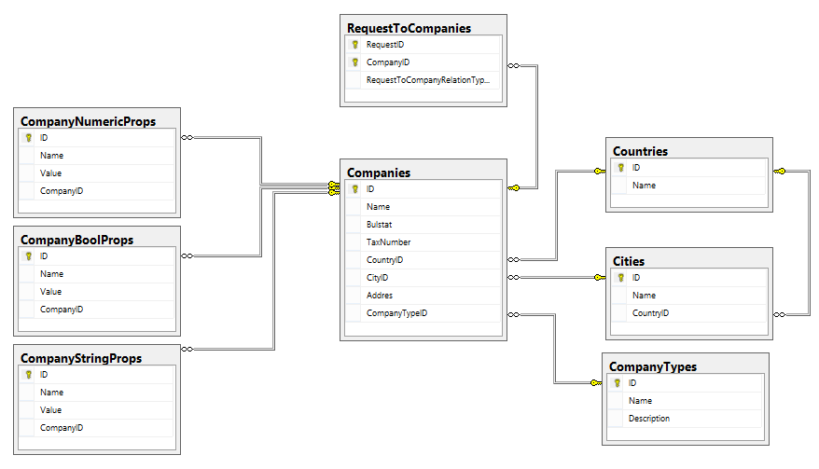

**Documents**

**Main properties**

* ID
* DocumentNumber

**Relations:**

* DocumentType -> Document has one type.  
  e.g.: Invoice, CMR …
* DocumentBoolProp -> Flexibility to add custom properties
* DocumentStringProp -> Flexibility to add custom properties
* DocumentNumericProp -> Flexibility to add custom properties

16.09.2020

Добавена е функционалност за редеве: DocumentRow  
Всеки ред има основни полета: ID, RowNumber, DocumentID  
+ props таблици.

Липсва и връзка към фирма, коя фирма издава фактура, на коя фирма се издава фактура.  
Товарителница CMR – всички 24 полета ?? **Според типа на документа се добавят custom props**

**Employee**

**Main properties**

* ID
* FirstName
* MiddleName
* LastName
* EGN
* BirthDate

**Relations**

* Gender -> Employee has one Gender
* EmployeeBoolProp -> Flexibility to add custom properties
* EmployeeStringProp -> Flexibility to add custom properties
* EmployeeNumericProp -> Flexibility to add custom properties
* **Request** -> Many to many relation. Each employee has many requests and each request has many employees. Table with relations is named: **RequestToEmployee**.   
  **Request to Employee** is many to many relation table with additional ingformation **Relation type**. Relation type explain business sense of the relationship.

**Missing relationa employee to company**

**Request**

**Main properties:**

* ID
* Number
* DateCreate
* IsDeleted

**Relations**

* RequestType -> Request’s type
* RequestStatus -> RequestStatus is current status of request.
* RequestStatusHistory -> Request status history is table, where are all previous statuses for request
* Documents -> Request has list of related documents.
* Company -> Request has many companies. In table RequestToCompanies is relation with additional information about it. RequestToCompanyRelationType is table with name and description of relation between Request and Company.
* Employee -> Request has many employees. In table RequestToEmployee is relation with additional information about it. RequestToEmployeeRelationType is table with name and description of relation between Request and Employee.
* Load -> Request has many loads.
* LoadingUnloadingPoints (LUP) -> Request has many LUP  
  **LUP has one Request.**

**Load**

**Main properties:**

* ID
* Name
* Comment

**Relations**

* PackageType -> Load has package type.
* Request -> Load has only one request.
* LoadingUnloadingPoint (LUP) -> Load has many LUPs.  
  Load has one loading point and has one unloading point.   
  Real word scenario: You have four boxes from same load address. You should unload them to four different addresses. User can manage this situation by creating different load for every one of those four boxes.

**Loading Unloading Point (LUP)**

**Main properties:**

* ID
* Type
* Date
* SenderReciever
* City
* Postcode
* Address

**Relations**

* **Request –** One LUP have only one Request.